**Name:**Satyam kumar singh Date:24-02-2023

**College:**National Institute of Technology Patna,Bihar

**Subject:** Assignment

**Q1.Compare and contrast for var,let,const?**

->>

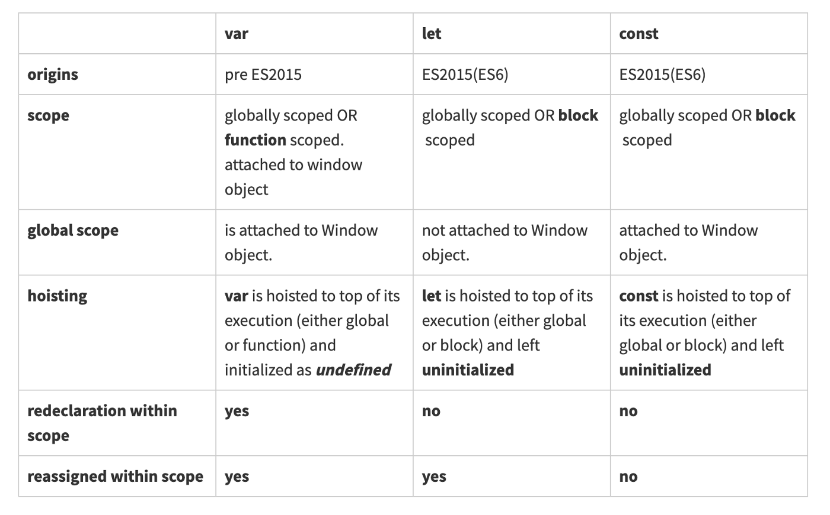

Q2. **Explain in brief about the different data types in JavaScript?**

-> JavaScript has 8 Datatypes

1.String  
2.Number  
3.Bigint  
4.Boolean  
5.Undefined  
6.Null  
7.Symbol  
8. Object

**The Object Datatype**

The object data type can contain:

1. An object  
2. An array  
3. A date

## **JavaScript Strings**

A string (or a text string) is a series of characters like "John Doe".Strings are written with quotes. You can use single or double quotes:

**Example**

// Using double quotes:  
let carName1 = "Volvo XC60";  
  
// Using single quotes:  
let carName2 = 'Volvo XC60';

## **JavaScript Numbers**

All JavaScript numbers are stored as decimal numbers (floating point).Numbers can be written with, or without decimals:

**Example**

// With decimals:  
let x1 = 34.00;  
// Without decimals:  
let x2 = 34;

## **JavaScript BigInt**

All JavaScript numbers are stored in a a 64-bit floating-point format.JavaScript BigInt is a new datatype (2020) that can be used to store integer values that are too big to be represented by a normal JavaScript Number.

**Example**

let x = BigInt("123456789012345678901234567890");

## **JavaScript Booleans**

Booleans can only have two values: true or false.

**Example**

let x = 5;  
let y = 5;  
let z = 6;  
(x == y)       // Returns true  
(x == z)       // Returns false

## **JavaScript Arrays**

JavaScript arrays are written with square brackets.Array items are separated by commas.The following code declares (creates) an array called cars, containing three items (car names):

**Example**

const cars = ["Saab", "Volvo", "BMW"];

## **JavaScript Objects**

JavaScript objects are written with curly braces {}.Object properties are written as name:value pairs, separated by commas.

## **Undefined**

In JavaScript, a variable without a value, has the value undefined. The type is also undefined.

**Example**

let car;    // Value is undefined, type is undefined

## **Empty Values**

An empty value has nothing to do with undefined.An empty string has both a legal value and a type.

**Example**

let car = "";    // The value is "", the typeof is "string"

**Q.3 What is Node.js?**

* Node.js is an open source server environment
* Node.js is free
* Node.js runs on various platforms (Windows, Linux, Unix, Mac OS X, etc.)
* Node.js uses JavaScript on the server

Node.js is an open source, cross-platform runtime environment for developing server-side and networking applications. Node.js applications are written in JavaScript, and can be run within the Node.js runtime on OS X, Microsoft Windows, and Linux.

Node.js also provides a rich library of various JavaScript modules which simplifies the development of web applications using Node.js to a great extent.

**Q.4 Explain in brief about ECMA Script?**

**->** ECMAScript is a scripting-language specification that was developed by ECMA International in order to create a standardized JavaScript implementation across all web browsers.

It is widely used for client-side scripting in web browsers, and it is also used for server-side scripting with node.js. ECMAScript is the successor to JavaScript, and it is backward-compatible with most JavaScript code.

ECMAScript 6 is the latest version of the specification which was released in 2015 that is widely adopted by all modern web browsers.